Dis-Eur-Venus-Czech Republic

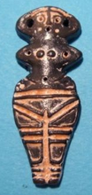

**Formal Label:**

**Accession Number:**

**Date or Time Horizon:** 6th millennium BCE

**Geographical Area:** Stara Zagora, Bulgaria

**Cultural Affiliation:** Neolithic

**Medium:**

**Dimensions:**

**Weight:**

**Provenance:** Archaeological Museum in Stara Zagora

**Condition: Museum Replica**

**Discussion:**

**References:**